FOUNDATION SCHOLARSHIP 2022-23

BUSINESS, ECONOMIC AND SOCIAL STUDIES
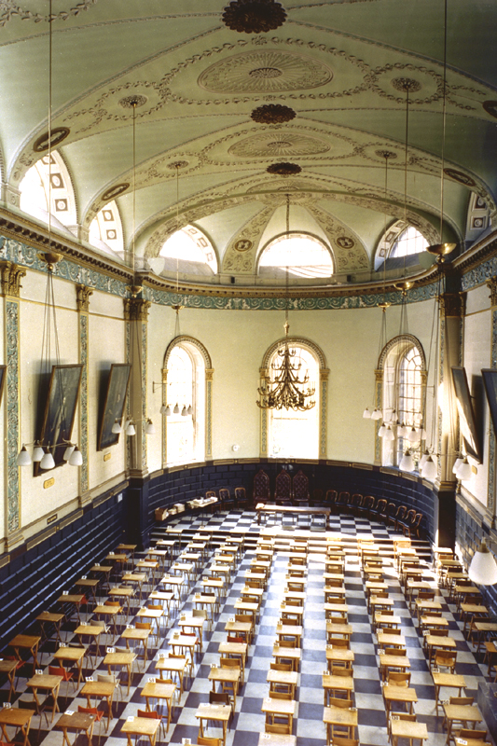

BESS FOUNDATION SCHOLARSHIP JANUARY 2023 – 4 PAPERS IN TOTAL

BRIEF PAPER DESCRIPTORS

BUSINESS
Paper 1 | ‘General’ paper designed to test candidates’ analytical, critical and discursive abilities by offering a choice of six questions of which students must choose two to answer. Candidates will be expected to Candidates will be expected to synthesize knowledge from a range of business modules, as well as from relevant social sciences, to address issues in the modern business world.
Paper 2 | ‘Fundamentals’. A paper on mandatory JF Business module designed to test students on the fundamentals of management and organisation including the nature and form of organisations, tools and techniques for management of organisations, and their role in social and individual well-being.
Paper 3 | 'Qualitative'. A paper which covers three Business Subjects requiring qualitative knowledge taught to students across all business degrees. Generally, the subjects included will be drawn from Organisational Behaviour, Entrepreneurship and Managing Climate Change.
ECONOMICS
Paper 1 | Economics I. The main focus of the questions will be material relating to module ECU22011 Intermediate Economics A. In contrast to annual exam papers, questions will be more general in nature. Questions may also draw on material from ECU11011 and ECU11012
Paper 2 | Economics II. The focus will be on material covered in module ECU22021, The Economy of Ireland A. Questions will be general in nature.
Paper 3 | Economics III. Questions covered will draw on material from the Introduction to Economics sequence, ECU11011 and ECU11012. Compared to annual exam papers, questions will be more general in nature.
Paper 4 | Quantitative Methods. Questions will draw mainly on material from ECU22031, Mathematical and Statistical Methods A, but may also draw on material from ECU11021 and ECU11022. Compared to annual exam papers, questions will be more general in nature.
POLITICAL SCIENCE
Paper 1 | General Paper (Students taking one or more SF Political Science modules)
Paper 2 | General Paper (Students with JF credits only in Political Science – not taking any SF Political Science modules)
Paper 3 | History of Political Thought Paper
Paper 4 | Comparative Politics Paper
Paper 5 | International Relations Paper
SOCIOLOGY
Paper 1 | A 'foundations’ paper which draws on the material which the students learnt in Semesters 1 and 2 in their first year in Introduction to Sociology 1 and 2. Students are offered six questions from which they answer two.
Paper 2 | A 'general’ paper designed to test candidates’ analytical, critical and discursive abilities. Students are provided with a number of readings on two topics: cultural capital and social capital. Two questions on each topic are provided in two sections and students answer one question from each section.
Paper 3 | A 'theory and methods' paper. Students are presented with six questions overall in two sections from which they answer one question from each section and two in total. Section 1 will have three questions which draw on the material taught in Social Theory Semester 1 (SOU22061). Section 2 will have three questions which draw on the material from Introduction to Social Research Semester 1 (SOU22011).
Paper 4 | A 'core topics’ paper. Students are presented with six questions overall in two sections from which they answer one question from each section and two in total. Section 1 will have three questions which draw on the material taught in Gender, Work and Family Semester 1 (SOU22021). Section 2 will have three questions which draw on the material from Power, State and Social Movements Semester 1 (SOU22041).

CREDIT PROFILES AND PAPER CHOICE
 | Pathway | Credit profile (SF) | Paper choices (4 papers in total)
1a.b | Single Honor | S1 (40 ECTS) + OM/TE (20 ECTS) | 3 Papers in S1, and 1 Paper in S2, S3, or S4 from JF Yr
2a.b.c.d | Major with minor | S1 (40 ECTS) + S2 (20 ECTS) | 2 Papers in S1 and 2 Papers in S2
 |  |  | or
 |  |  | 3 Papers in S1 and 1 Paper in S2
3d | Joint Honor | S1 (20 ECTS) + S2 (20 ECTS) +  OM/TE (20 ECTS) | 2 Papers in S1 and 2 Papers in S2
3a.b | Three subjects | S1 (20 ECTS) + S2 (20 ECTS) +  S3 (20 ECTS) | 1 Paper in S1, 1 Paper in S2, 1 Paper in S3 and another Paper from either S1, S2, or S3
 |  |  | or
 |  |  | 2 Papers in S1 and 2 Papers in S2

See following pages for specifics:

(1a,b) SINGLE HONORS – 3 Papers from Subject 1, 4th Paper from any of the four Subject from the JF Year
ECONOMICS |  |  | POLITICAL SCIENCE |  |  | SOCIOLOGY |  |  | BUSINESS
Mandatory | Paper 1 |  | Mandatory | Gen Paper 1 |  | Soc | Paper 1 |  | Mandatory | Paper 1
Mandatory | Paper 2 |  | PolSci | Paper 3,4 or 5 |  | Soc | Paper 2 |  | Mandatory | Paper 2
Mandatory | Paper 4 |  | PolSci | Paper 3,4 or 5 |  | Soc | Paper 3 or 4 |  | Mandatory | Paper 3
Bus | Paper 2 or |  | Econ | Paper 3, or |  | Econ | Paper 3, or |  | Econ | Paper 3, or
PolSci | Paper 2, or |  | Bus | Paper 2, or |  | PolSci | Paper 2, or |  | PolSci | Paper 2, or
Soc | Paper 1 |  | Soc | Paper 1 |  | Bus | Paper 2 |  | Soc | Paper 1

(2a,b,c,d) MAJOR WITH MINOR – 2 Papers from Major / 2 Papers from Minor; OR 3 Papers from Major / 1 Paper from Minor)
ECONOMICS Major |  |  | POLITICAL SCIENCE Major |  |  | SOCIOLOGY Major |  |  | BUSINESS Major
Econ | Paper 1,2 or 4 |  | Mandatory | Gen Paper 1 |  | Soc | Paper 2 |  | Mandatory | Paper 1
Econ | Paper 1,2 or 4 |  | PolSci | Paper 3,4 or 5 |  | Soc | Paper 3 or 4 |  | Bus | Paper 2 or 3
OR |  |  | OR |  |  | OR |  |  | OR
Mandatory | Paper 1 |  | Mandatory | Gen Paper 1 |  | Soc | Paper 1 |  | Mandatory | Paper 1
Mandatory | Paper 2 |  | PolSci | Paper 3,4 or 5 |  | Soc | Paper 2 |  | Mandatory | Paper 2
Mandatory | Paper 4 |  | PolSci | Paper 3,4 or 5 |  | Soc | Paper 3 or 4 |  | Mandatory | Paper 3

ECONOMICS Minor |  |  | POLITICAL SCIENCE Minor |  |  | SOCIOLOGY Minor |  |  | BUSINESS Minor
Econ | Paper 1,2 or 4 |  | Mandatory | Gen Paper 1 |  | Soc | Paper 2 |  | Mandatory | Paper 1
Econ | Paper 1,2 or 4 |  | PolSci | Paper 3,4 or 5 |  | Soc | Paper 3 or 4 |  | Mandatory | Paper 2
OR |  |  | OR |  |  | OR |  |  | OR
Econ | Paper 1,2 or 4 |  | Mandatory | Gen Paper 1 |  | Soc | Paper 3 or 4 |  | Mandatory | Paper 2

(3a,b) THREE SUBJECTS – 1 Paper from each Subject and 4th paper from within any of 3 chosen Subjects; OR 2 Papers from Subject 1 and 2 Papers from Subject 2
ECONOMICS |  |  | POLITICAL SCIENCE |  |  | SOCIOLOGY |  |  |  | BUSINESS
Econ | Paper I,2 or 4 |  | Mandatory | Gen Paper 1 |  | Soc | Paper 3 or 4 |  |  | Mandatory | Paper 2
And 1 Paper for each of S2 & S3 |  |  | And 1 Paper for each of S2 & S3 |  |  | And 1 Paper for each of S2 & S3 |  |  |  | And 1 Paper for each of S2 & S3
If taking a second Econ Paper (Paper 4), choose |  |  | If taking a second PolSci Paper (Paper 4), choose |  |  | If taking a second Soc Paper (Paper 4), choose |  |  |  | If taking a second Bus  Paper (Paper 4), choose
Econ | Paper 1,2 or 4  (not already chosen above) |  | PolSci | Papers 3,4 or 5 |  | Soc |  | Paper 2 |  | Mandatory |  | Paper 1
OR |  |  | OR |  |  | OR |  |  |  | OR
Econ | Paper 1,2 or 4 |  | Mandatory | Gen Paper 1 |  | Soc |  | Paper 2 |  | Mandatory |  | Paper 1
Econ | Paper 1,2 or 4 |  | PolSci | Paper 3,4 or 5 |  | Soc |  | Paper 3 or 4 |  | Mandatory |  | Paper 2

(3d) JOINT HONOR– 2 Papers from each Subject
ECONOMICS |  |  | POLITICAL SCIENCE |  |  | SOCIOLOGY |  |  | BUSINESS
Econ | Paper 1,2 or 4 |  | Mandatory | Gen Paper 1 |  | Soc | Paper 2 |  | Mandatory | Paper 1
Econ | Paper 1,2 or 4 |  | PolSci | Paper 3,4 or 5 |  | Soc | Paper 3 or 4 |  | Mandatory | Paper 2

